Positive Pay Process

User Permission
- Positive Pay setup must be completed in NuPoint prior to granting access in Digital Banking.
- Access to Positive Pay is located on the Checking Account tab below ACH and Wire permissions.

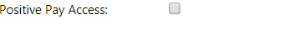

Digital Banking User Process

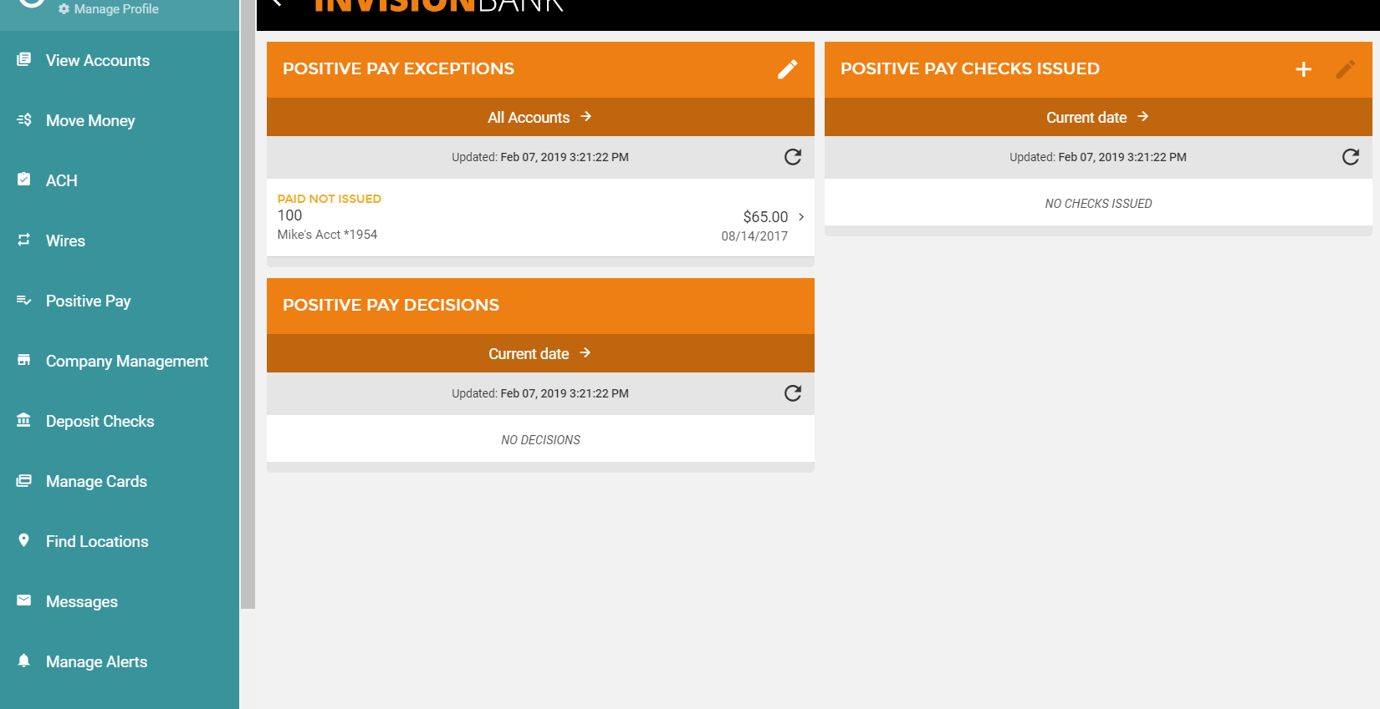

Step 1: Customer may add Issued Checks or Import a file
** Default cutoff for Positive Pay additions and decisions is 3:00 p.m. CST.
Manually adding a check:
- Click “+” to manually add checks or import a file.

- Select input method. The user has the option to save import file formats as a template for future use.

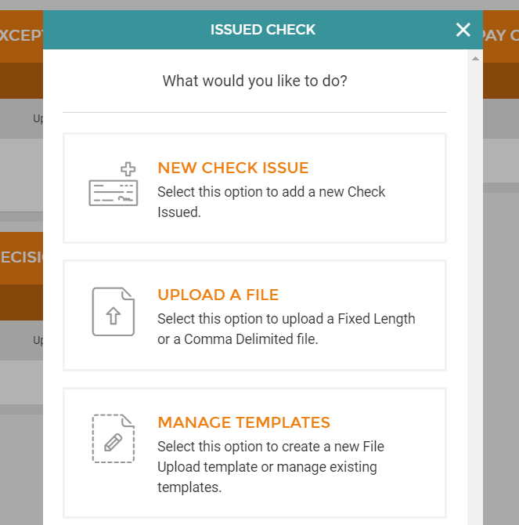

If Customer Imports File
**File can be Fixed Length or CSV (comma-separated values) / Comma Delimited
If Comma Delimited
- User will select the fields that are contained in the file. The fields must be in the order they are saved in the CSV file.
- Enter the number of lines to skip if any header information is included in the file.
- If amounts in file exclude decimals, select that option at the end of the upload screen.

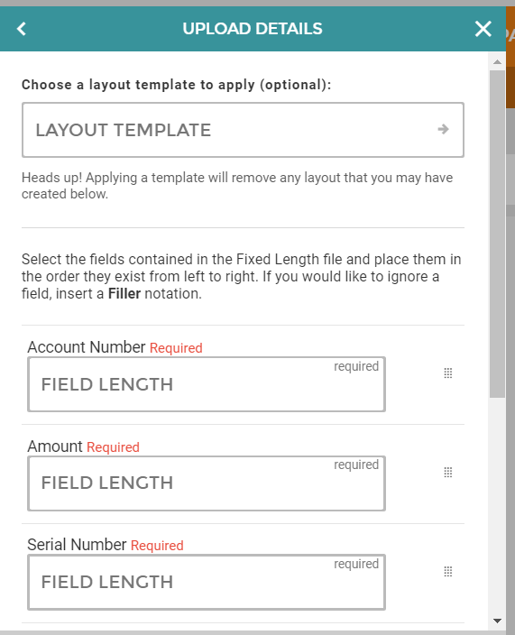

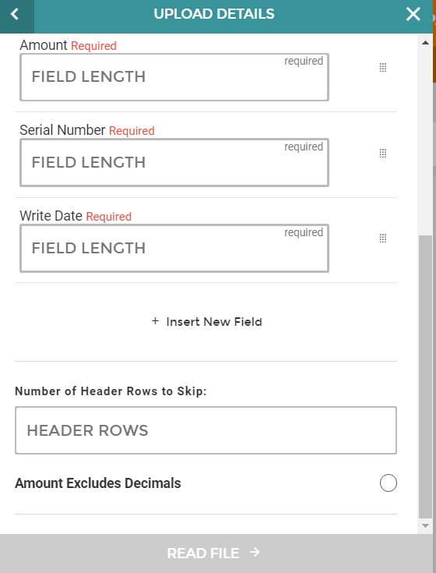

Step 2: Exceptions
- Any exceptions will be listed for the user to decision.
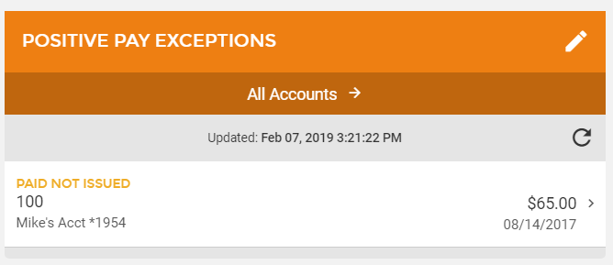
- Click on the item to select the appropriate decision.
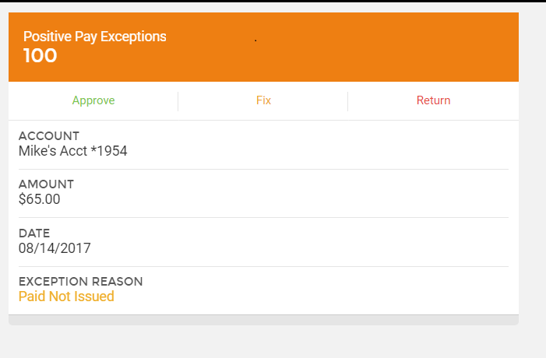

Any previous decisions will be listed in on the main Positive Pay page and can be displayed by a date range.
